6-1 Skills Practice
Logarithms and Logarithmic Functions

Write each equation in exponential form.
1. $\log_{3}$ 243 = 5 2. $\log_{4}$ 64 = 3

3. $\log_{9}$ 3 = $\frac{1}{2}$ 4. $\log_{5}$ $\frac{1}{25}$ = –2

Write each equation in logarithmic form.
5. $2^{3}$ = 8 6. $3^{2}$ = 9

7. $8^{-2}$ = $\frac{1}{64}$ 8. ${\left(\frac{1}{3}\right)}^{2}$ = $\frac{1}{9}$

Evaluate each expression.

9. $\log_{5}$ 25 10. $\log_{9}$ 3

11. $\log_{10}$ 1000 12. $\log_{125}$ 5

13. $\log_{8}$ 512 14. $\log_{27}$ $\frac{1}{3}$

Graph each function.

15. $f\left(x\right)=\log_{4} x$ 16. f(x) = –$\log_{4} (x-3)$
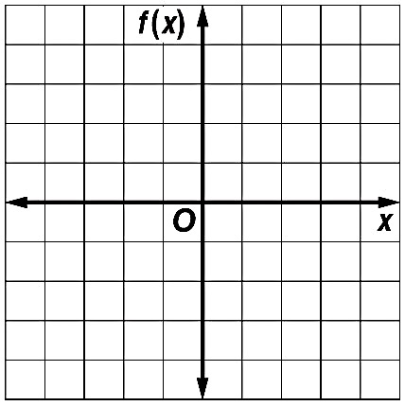

17. $f\left(x\right)= \log_{3}(x + 3) – 2$ 18. f(x) = – $\log_{5}$ x + 2

