6-1 Practice
Logarithms and Logarithmic Functions

Write each equation in exponential form.
1. $\log_{6}$ 216 = 3 2. $\log_{2}$ 64 = 6 3. $\log_{3}$ $\frac{1}{81}$ = –4

Write each equation in logarithmic form.
4. $5^{3}$ = 125 5. $7^{0}$ = 1 6. $3^{4}$ = 81

Evaluate each expression.
7. $\log_{3}$ 81 8. $\log_{10}$ 0.0001 9. $\log_{2}$ $\frac{1}{16}$ 10. $\log_{\frac{1}{3}}$ 27

11. $\log_{9}$ 1 12. $\log_{8}$ 4 13. $\log_{7}$ $\frac{1}{49}$ 14. $\log_{6}$ $6^{4}$

Graph each function.
15. $f\left(x\right)=\log_{2} x$ 16. f(x) = –$\log_{4}$ x

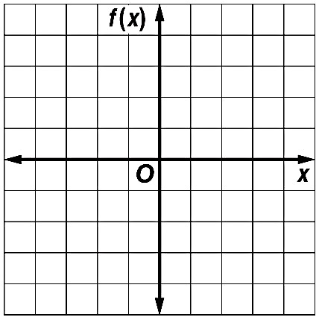

17. $f\left(x\right)=\log_{3}(x-2)$ 18. $f\left(x\right)=-2\log_{2} x$

19. ${f\left(x\right)=log}_{3}\left(x-2\right)+3$ 20. $f\left(x\right)={-3 log}_{4}\left(x+1\right)-2$

